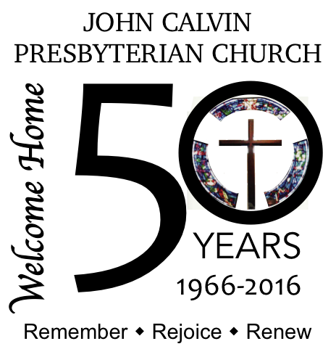
50 years ago…
…. did you know?

Fifty years ago, John Calvin Presbyterian Church was constituted, but we didn’t call our first pastor until 1967…
As what would become JCPC was just getting started, the Presbytery borrowed Rev. Jack Moore from the Texas Presbytery where, having excellent organizing skills, he worked to start new churches by gathering interested people in the community and leading them through the early stages of church growth. Rev. Moore served 4 months to be followed by the Presbytery Executive, Dr. Russell T. Nunan (a retired U.S. Navy Chaplain who served in WWII), who led services in the trailer until the Pastor Nominating Committee (PNC) was formed and the first pastor was called.
Rev. Robert E. (Bob) Malsbary was called by the first PNC and installed on April 30, 1967. Rev. Malsbary had been pastor of First Presbyterian Church, Andalusia, Alabama for the previous 6 years, just out of Columbia Theological Seminary. Unusually, Rev. Malsbary stayed on at JCPC for 33 years, until his retirement in August 2000. What a wonderful opportunity for this young church and its new pastor. We will discuss much of the accomplishments of those 33 years in subsequent articles. Rev. Malsbary was a beloved pastor, highly esteemed by his congregation. His retirement closed the first chapter of the life of JCPC.
Just a few months after Rev. Malsbary’s retirement, and before a new PNC was even elected, JCPC experienced an arson fire that destroyed the sanctuary, offices, and several classrooms. What a testament to the congregation that they drew together and kept their church going, but that is a story for another day. Several months after the fire, Rev. Michael B. Mann came in as the permanent interim pastor to help the congregation through the process of assessing it strengths and needs and to develop a guide for future mission in the community. Rev. Mann served for the 18 months allowed then was followed by a temporary interim pastor, Rev. Oliver T. Lee.
In the spring of 2002, the new PNC was nominated and began working to call a new permanent pastor. In April 2003, the congregation called Rev. Harry A. Brown to be JCPC’s new pastor. Arriving from York, Nebraska in July, Rev. Brown delivered his first sermon at JCPC on July 6, 2003, thus starting another chapter in the life of JCPC. How lucky this church has been to have two such wonderful pastors in 50 years!

But when did the playschool appear? And you still haven’t heard much about the trailer! Stay tuned for next month’s installment on the history of John Calvin Presbyterian Church as we celebrate 50 years serving Christ and this community.

