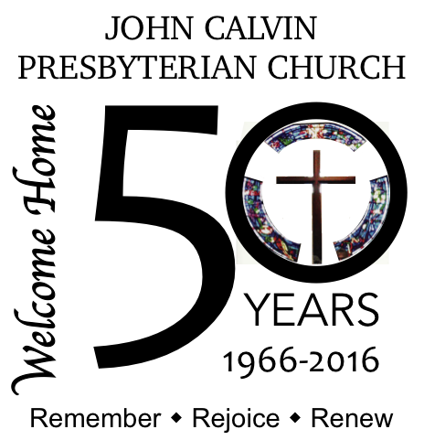
50 years ago…
…. did you know?

Fifty years ago, the first Worship Service on the property of John Calvin Presbyterian Church was held on Palm Sunday, April 3, 1966…in a doublewide trailer!
As John Calvin Presbyterian Church was getting started, the fledgling congregation met for Worship at the Bissonet-Maned Downs clubhouse. The group grew and Presbytery installed a specially designed doublewide trailer where the first service as held on the property on Palm Sunday, 1966. According to notes from the period, this special trailer had two detachable pieces that when set up, had the sides that came down to triple the floor space, creating seating for 100 people in folding chairs…sitting very close to one another!
The growing church quickly ran out of space in the trailer and plans were made for the first building, which would include sanctuary, classroom, and office space. The new building was completed in 1970.
Soon after completion of the first building, the Playschool was started and grew. At the same time, mission to the local community grew through support for Alcoholics Anonymous meetings. These two very different and very important needs were supplied through the use of the same 4 classrooms. The need for more space was clear and plans were made for more rooms. The Christian Education Building was completed in 1973. At this point the buildings that housed John Calvin Presbyterian Church were settled for a few years.
Did you know that the first sanctuary was never intended to be the permanent Worship space? That’s what the records indicate. In the 80’s the semi-permanent nature of the sanctuary was realized and plans were drawn up for a new sanctuary, office space, and better community space. Unfortunately, with the downturn of the oil industry, these plans had to be set aside. It wasn’t until the late 90’s when they were brought back out. “Legacy 2000” was the name for a two-phased approach to revitalization of the John Calvin Presbyterian Church buildings. Ground was broken for the phase 1, a multi-purpose building, in 1998. This is what we call our Fellowship Hall today, with classrooms, an industrially equipped kitchen, and more space for the Playschool.
You know what happened in late November 2000 – an arson fire destroyed the sanctuary, offices and the original classrooms. That is a story for another issue. Fortunately, plans for phase 2 could be resurrected and the new sanctuary, new office space and a wonderful community space, everything appreciated today, was dedicated on November 10, 2002. A new pipe organ, replacing the one destroyed in the fire, was dedicated in 2003.
Finally, as part of our 50th Year Celebration, new stained glass window inserts in the side windows were installed and dedicated on April 17, 2016. Our church is growing still!

But what about the Playschool? And, how did we survive the fire?!? Stay tuned for next month’s installment on the history of John Calvin Presbyterian Church as we celebrate 50 years serving Christ and this community.

