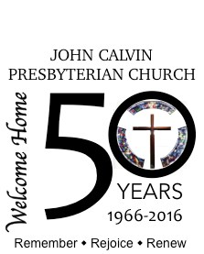
April 2016

50 years ago…
…. did you know?

Fifty years ago when a group of Presbyterians got together to form this new church, they purchased land, and began organizing. But how do you find the people for a new church in a brand new, growing community? The area was expanding with contractors building speculative houses, and corporations were transferring in people from all over the country. Many of the new people moving into the area were Presbyterian from previous affiliation.

Early in 1966 the search began for “lost” Presbyterians. A door-to-door and neighbor-to-neighbor evangelism began! The story goes that Kate Franklin opened the door to a man searching for “lost” Presbyterians. When asked, “Do you have any?”, she replied, “Well, I’m not, but there’s one sitting on his duff in the back room!”. Kate and her husband Ray become two of the earliest members. Kate served on the first pastor nominating committee!

Worship began in local homes, then moved to the Bissonet-Maned Downs clubhouse, a hub of community communication. As the small congregation began to grow, the Presbytery felt that a more permanent place was needed and installed a double-wide trailer on the newly purchased property on the corner of Transcontinental and Glendale streets. It was a specially built trailer with detachable pieces. When set up the floor space tripled to seat just over 100 people on folding chairs…sitting very close to one another.

The first worship service in the trailer was held on Palm Sunday, April 3rd, 1966, accompanied by a small electronic organ.

What happened next? Who was the Pastor? How long did we stay in the trailer? Stay tuned for next month’s installment on the history of John Calvin Presbyterian Church as we continue the celebration of 50 years serving Christ.

