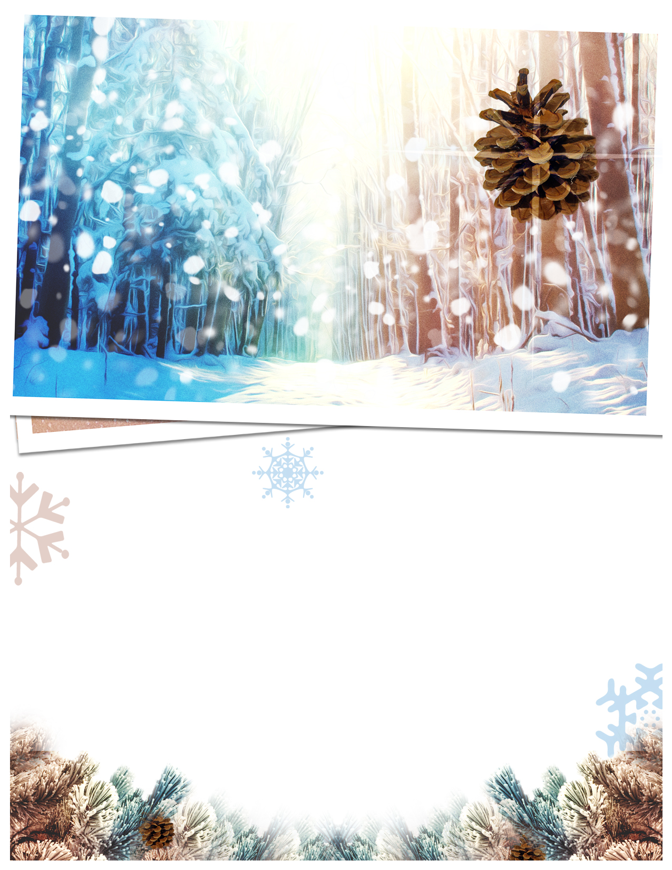
Calvin Commentary
Monthly Newsletter of John Calvin Presbyterian Church, Metairie LA January 2015
As we begin a new year this Sunday, January 4, our 10:30 a.m. service will include the celebration of Holy Communion.
On January 18 the 8:30 a.m. service will include the celebration of Holy Communion.
In the 10:30 a.m. worship service on January 11, new elders recently elected to serve on the Session will be ordained and installed.
We extend our appreciation to those completing their terms of service in the class of 2014.

New Year’s is a time for resolutions and new
beginnings. We hope one of yours will be to
make Sunday School (9:15 a.m.) and Worship
(8:30 & 10:30 a.m.) each Sunday morning a
standing commitment. By living this discipline
in your family’s life you open the door to
countless ways by which God wants to bless
you, refueling your heart and life, by giving
you the strength and resources to meet life’s
challenges.

Pastor’s Pen
A New Year
Ecclesiastes 1:9; 2 Corinthians 5:17

What has been is what will be, and what has been done is what will be done says the writer of Ecclesiastes. Then he adds there is nothing new under the sun. This is not what we want to hear as we enter a new year. We have just finished a year that was filled with illness, death, poverty, terrorism and war and we want something new. In fact, we long in our deepest being for something new. We want the New Year to be different so it’s pretty sobering to be told in scripture that nothing is going to change.
Fortunately this is not the only voice in scripture. In Second Corinthians the apostle Paul says if anyone is in Christ they are a new creation; everything old has passed away; everything has become fresh and new. The difference between the two is that Paul has met the risen Christ on the Damascus road. This is what Christ does, he makes us new creations. It might seem that we are consigned to an endless cycle of failure and disappointment that there is nothing new. But the good news is when Christ comes into our lives everything becomes fresh and new.
You are wise enough to understand how the newness comes. We aren’t suddenly whisked out of our old worlds, the way Scrooge was carried away by those wonderful ghosts in “A Christmas Carol”. We are left right in the worlds where we are, looking at the same old scenery and the same old people but everything looks different to us. The change comes about in the way we see everything, the way we relate to it, and the way we deal with it.
As we enter a new year we hope it will be better than the last year. We hope that there will be peace and good health. We want things to be different. And the promise of the gospel is that they will be. But it’s not because the world will be different. It happens through our being different, our seeing things with new eyes, our living our lives differently.
The world will probably go on pretty much as it has, only wilder and faster than ever. There will be medical breakthroughs and technological discoveries. Maybe we’ll find a cure for the common cold or a cure for cancer. Maybe artificial intelligence will develop to the point that computers are self-programming. Maybe self-driving cars will advance to the point that they become the norm. But the really great advances, the ones that will make everything seem new and different are made in our hearts. This is where our work is cut out for us. This is where the true difference in the next year will arise. It isn’t terribly hard. It’s a matter of accepting what God has already done in Christ. God has given us a new life, a new way of seeing and if we will focus on this it will make us new creations who see things in new ways.

In Christ’s Service,
Rev. Harry Brown

Join Us for Worship in 2015!

1


(article cont.)

2

2

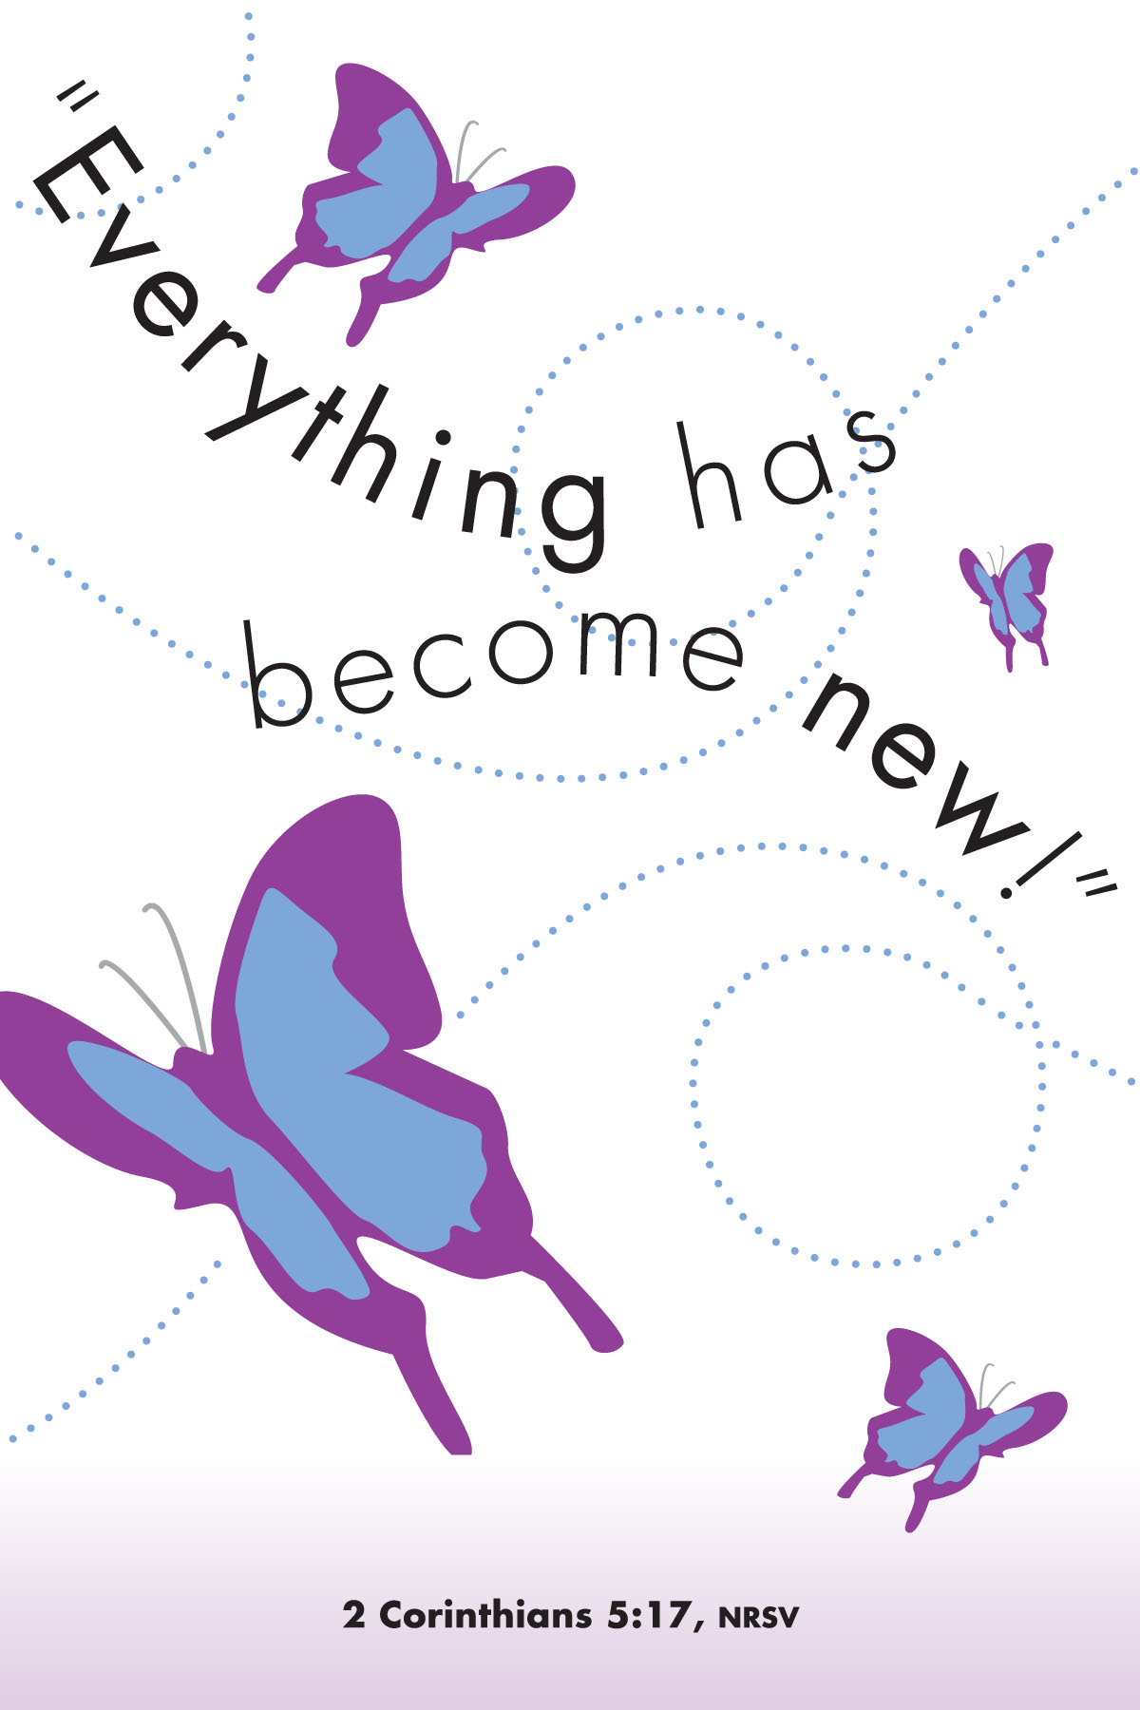


Music Notes
By William R Memmott

A NEW YEAR FOR THE MINISTRY OF MUSIC
3

As I write this, we have just performed Saint-Saens' "Christmas Oratorio" as our musical offering for Advent/Christmas 2014. What comes next?
Early in January our choir will join with other choirs in a Workshop and Concert led by 89 year old Alice Parker, composer and arranger. She is best known for her collaborations with the great Robert Shaw in producing wonderful original compositions and arrangements as sung by the famous Robert Shaw Chorale. Her appearance in New Orleans will be featured at a concert on Sunday afternoon, January 11 at 3:00 p.m. at Holy Name Church, Tulane University on St. Charles Avenue. Mark your calendars for this rare treat.
And then, our choir, soloists and guest orchestra will perform the Passion and Resurrection portion of the greatest oratorio ever written, George Frideric Handel's "Messiah." It was written in 1741 during a period of great difficulty for Handel. Since he was a relentless optimist whose faith in God sustained him through every difficulty, he wrote this masterpiece in 24 days, barely eating and experiencing great moments of almost mystical inspiration. We shall sing the work in as close to the Handel version as is now known. We last sang the work in 2009 with a much reduced choir. So, be ready to stand for the "Hallelujah Chorus," a tradition begun by King George II. Mark your calendars for this Palm Sunday celebration.
It is the time of the year when we invite new singers to join our choir and new players to join our weekly orchestra.
Soli Deo Gloria

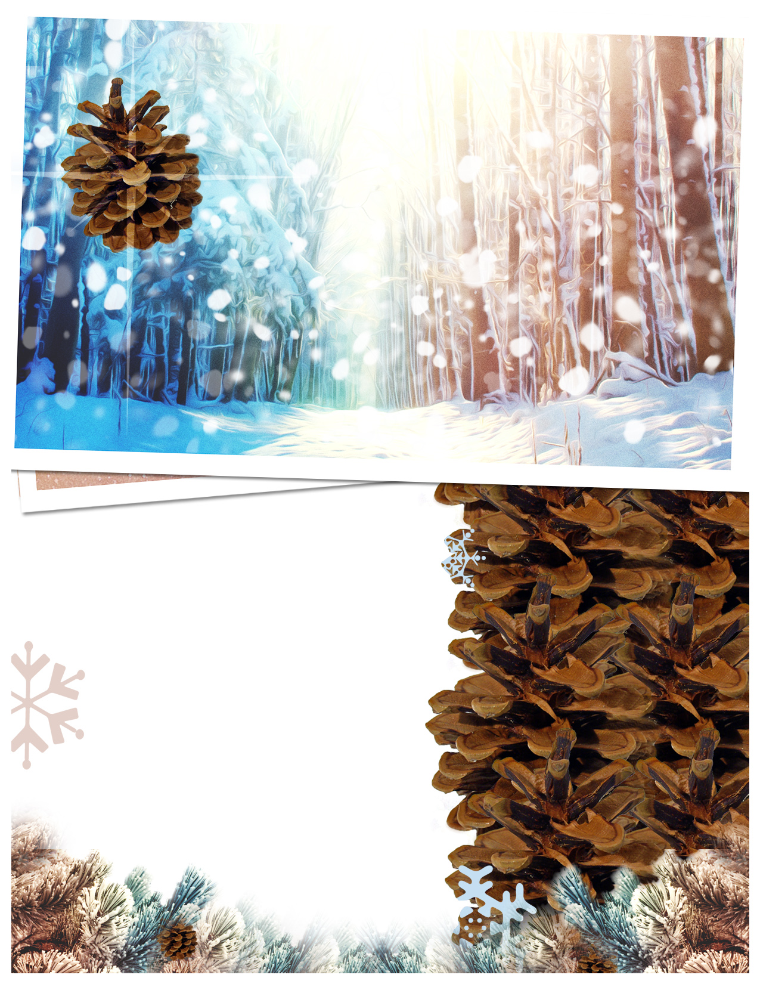

Happy Birthday!

4

A Note from theTreasurer:
As we move from 2014 to 2015, thank you, members and friends of JCPC, for your generosity toward our church’s budget. JCPC is grateful to all who gave during the year with their regular pledges to the church, and to those who gave special, “additional pledges”.
The financial books will remain open until January 6 for anyone wishing to complete their 2014 pledge.
2015 Offering envelopes are in the narthex near the entrance. If you do not see your box, please call the church office.

Warmest Regards,
Dianne Boan
SESSION 2015
The Session approved the following elders to lead and serve on the ministry teams in the New Year. They, with volunteers from the congregation, will be planning and leading the church’s ministries in 2015.

Clerk of Session/Moderator ProTem
Bill Bottomley

Christian Education
Jon O’Regan, Chair
Sue Crawford
Greg Freudenthal
Laurie Robinson
Wayne Tracy
Facilities
Buddy Haw
Outreach
Sharon Fortin, Chair
Richard Britson
Sue Crawford
Barbara McHan
Suzanne Wooderson

Financial Volunteers:
David Garland
Playschool Bookkeeper
Dianne Boan
Treasurer
Playschool
Sheryl Wise, Chair
Kathy Begg

Worship
Ron Palmisano, Chair
Danny Cain, Vice Chair
Jeanette Spiess
William Memmott
Ray Weindel

6 Edye Trail
9 David Garland
9 Sharon Fortin
10 Jeff Fernandez
11 Ed Magri
14 Eva Mace
15 Jeanette Spiess
16 Dennis Cali II
22 Robin Bone
23 Claire Russo
24 Sheryl Wise
24 Valerie Corcoran
26 Jon O’Regan
27 Scott Crawford
29 Madison Prince

Save the Date: White Tablecloth Dinner
January 22, 2015 at Zea’s Resturant at Clearviw Mall
Menu will be forthcoming. Cost: $30 per person
Gathering 6:30 p.m. and Dinner 7:00 p.m.
Host: Sue Crawford

